GitHub Task: Lexical Analyzer & Token Counter

Objective:
Develop a C program that reads a source-code file and performs lexical analysis by identifying and counting different types of tokens.
Problem Statement:
The program identifies the following token types:
- Keywords
- Identifiers
- Operators
- Constants/Literals
- Separators/Delimiters
- Special Symbols
- Comments
Lexical Analyser Transition diagram:
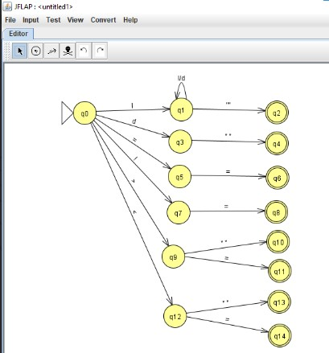
Source Code:
#include <stdio.h>
#include <ctype.h>
#include <string.h>
int main()
{
FILE *fp;
char ch;
char word[100];
int i, j;
int in_include = 0;
int keywords = 0;
int identifiers = 0;
int constants = 0;
int operators = 0;
int special_symbols = 0;
int string_literals = 0;
int preprocessor = 0;
int headers = 0;
int total_tokens = 0;
char *keyword_list[MAX_KEYWORDS] = {
"auto", "break", "case", "char",
"const", "continue", "default", "do",
"double", "else", "enum", "extern",
"float", "for", "goto", "if",
"int", "long", "register", "return",
"short", "signed", "sizeof", "static",
"struct", "switch", "typedef", "union",
"unsigned", "void", "volatile", "while"
};
fp = fopen("source.c", "r");
if (fp == NULL)
{
printf("Error: Cannot open source.c\n");
return 1;
}
printf("\n===============================================\n");
printf(" LEXICAL ANALYSIS\n");
printf("===============================================\n");
printf("%-25s %-25s\n", "TOKEN", "TYPE");
printf("-----------------------------------------------\n");
while ((ch = fgetc(fp)) != EOF)
{
if (isspace(ch))
continue;
if (ch == '#')
{
printf("%-25s %-25s\n", "#", "Preprocessor Symbol");
preprocessor++;
total_tokens++;
while ((ch = fgetc(fp)) != EOF && isspace(ch));
if (ch != EOF)
{
i = 0;
word[i++] = ch;
while ((ch = fgetc(fp)) != EOF && isalpha(ch))
{
word[i++] = ch;
}
word[i] = '\0';
if (strcmp(word, "include") == 0)
{
printf("%-25s %-25s\n",
"include",
"Preprocessor Directive");
preprocessor++;
total_tokens++;
in_include = 1;
}
if (ch != EOF)
ungetc(ch, fp);
}

continue;
}
if (in_include && ch == '<')
{
i = 0;
word[i++] = ch;

while ((ch = fgetc(fp)) != EOF && ch != '>')
{
word[i++] = ch;
}
if (ch == '>')
word[i++] = ch;
word[i] = '\0';
printf("%-25s %-25s\n",
word,
"Header File");
headers++;
total_tokens++;
in_include = 0;
continue;
}
if (isalpha(ch) || ch == '_')
{
i = 0;
word[i++] = ch;
while ((ch = fgetc(fp)) != EOF &&
(isalnum(ch) || ch == '_'))
{
word[i++] = ch;
}
word[i] = '\0';

j = 0;
while (j < MAX_KEYWORDS)
{
if (strcmp(word, keyword_list[j]) == 0)
break;
j++;
}
if (j < MAX_KEYWORDS)
{
printf("%-25s %-25s\n",
word,
"Keyword");

keywords++;
}
else
{
printf("%-25s %-25s\n",
word,
"Identifier");

identifiers++;
}
total_tokens++;
if (ch != EOF)
ungetc(ch, fp);
continue;
}
if (isdigit(ch))
{
i = 0;
word[i++] = ch;
while ((ch = fgetc(fp)) != EOF &&
isdigit(ch))
{
word[i++] = ch;
}
word[i] = '\0';
printf("%-25s %-25s\n",
word,
"Constant");
constants++;
total_tokens++;
if (ch != EOF)
ungetc(ch, fp);
continue;
}
if (ch == '"')
{
i = 0;
word[i++] = ch;
while ((ch = fgetc(fp)) != EOF &&
ch != '"')
{
word[i++] = ch;
}
if (ch == '"')
word[i++] = ch;
word[i] = '\0';
printf("%-25s %-25s\n",
word,
"String Literal");
string_literals++;
total_tokens++;
continue;
}
if (ch == '+' || ch == '-' ||
ch == '*' || ch == '/' ||
ch == '=' || ch == '<' ||
ch == '>' || ch == '%' ||
ch == '!' || ch == '&' ||
ch == '|')
{
printf("%-25c %-25s\n",
ch,
"Operator");
operators++;
total_tokens++;
in_include = 0;
continue;
}
if (ch == '(' || ch == ')' ||
ch == '{' || ch == '}' ||
ch == '[' || ch == ']' ||
ch == ';' || ch == ',' ||
ch == '.')
{
printf("%-25c %-25s\n",
ch,
"Special Symbol");
special_symbols++;
total_tokens++;
in_include = 0;
continue;
}
in_include = 0;
}
fclose(fp);
printf("-----------------------------------------------\n");
printf(" TOKEN COUNTS\n");
printf("-----------------------------------------------\n");
printf("Keywords : %d\n", keywords);
printf("Identifiers : %d\n", identifiers);
printf("Constants : %d\n", constants);
printf("Operators : %d\n", operators);
printf("String Literals : %d\n", string_literals);
printf("Special Symbols : %d\n", special_symbols);
printf("Preprocessor Tokens : %d\n", preprocessor);
printf("Header Files : %d\n", headers);
printf("-----------------------------------------------\n");
printf("Total Tokens : %d\n", total_tokens);
printf("===============================================\n");
return 0;
}

Sample Input

int i = 1;
while (i <= 5) {
printf("%d", i);
i++;
}

Sample Output
Token Recognition Table:
TOKEN | TYPE
int | Keyword
i | Identifier
= | Operator
1 | Constant
; | Separator
while | Keyword
( | Separator
i | Identifier
<= | Operator
5 | Constant
) | Separator
{ | Separator
printf | Identifier
( | Separator
"%d" | String Literal
, | Separator
i | Identifier
) | Separator
; | Separator
i | Identifier
++ | Operator
; | Separator
} | Separator

Token Count:

Token Type | Count
Keywords | 2
Identifiers | 5
Constants | 2
Operators | 3
String Literals | 1
Special Symbols / Separators | 10
Preprocessor Tokens | 0
Header Files | 0
Total Tokens | 23

GitHub Repository:
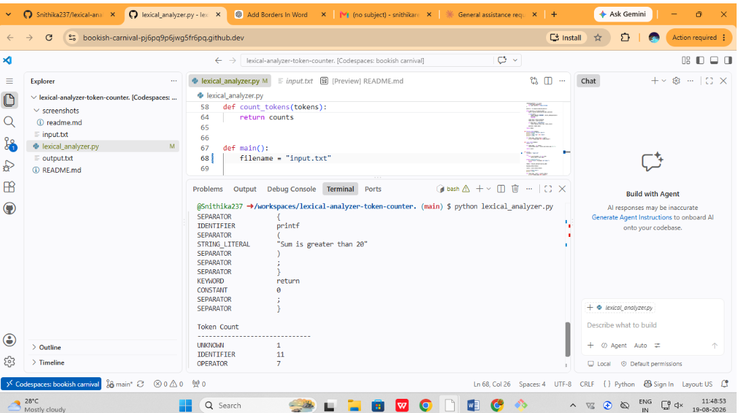
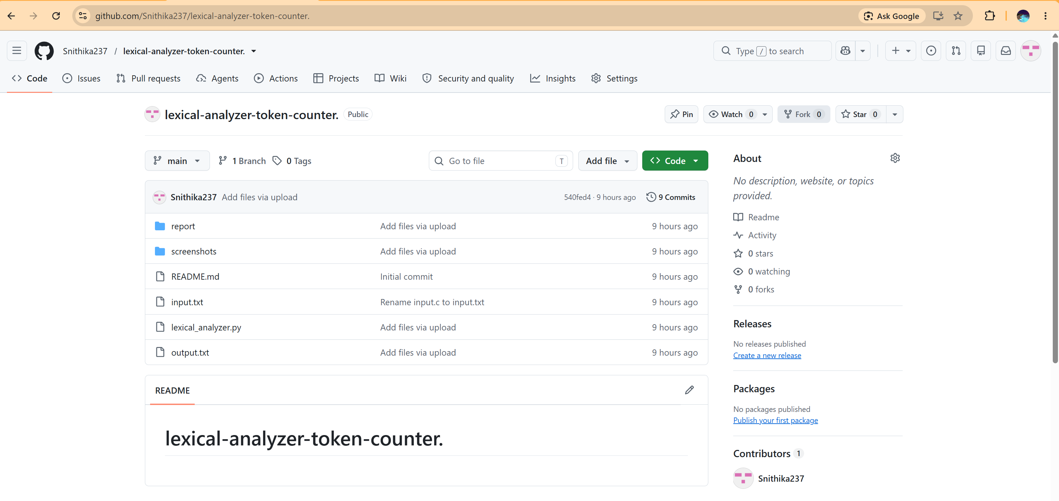

Conclusion

The lexical analyzer successfully identifies and classifies different types of tokens from a source-code file and counts the occurrences of each token type.

